CNS
Unit – 3
Q. Give short note on :
i) ICMP
In computer networking, the Internet Control Message Protocol (ICMP) acts as the network's messenger, primarily to report errors and help with diagnostics. It provides feedback on network conditions, but it doesn't fix the errors itself; it just informs the sender that something went wrong.

Simple Explanation
Imagine sending a postcard (a data packet) to a friend. The postal service (the network) tries its best to deliver it.
- Error Reporting: If the address is wrong, the post office can't deliver it. Instead of just throwing it away without a word, they send a "return to sender" notice (an ICMP message) back to you, the sender, explaining why it failed (e.g., "Destination Unreachable"). This allows your computer to understand the problem and potentially try a different approach.
- Diagnostics: Sometimes, you might want to check if your friend's mailbox is still there and how long it takes for a message to get there. You send a special "test" postcard (an ICMP echo request, also known as a ping) and ask for a reply. The friend sends one back (an ICMP echo reply), and you can time how long the whole process took and confirm connectivity.
Key Functions
- Error Messages: ICMP is used by network devices (like routers) to tell the sending device when a packet cannot be delivered.
- Network Troubleshooting: Tools like ping and traceroute rely on ICMP messages to test connectivity, measure the time it takes for data to travel (latency), and map the path packets take across the internet.
In essence, ICMP is the control and feedback mechanism for the Internet Protocol (IP), ensuring network devices can communicate issues and maintain smooth operations.
ICMP Packet Format
ICMP header comes after IPv4 and IPv6 packet header. In the ICMP packet format, the first 32 bits of the packet contain three fields:
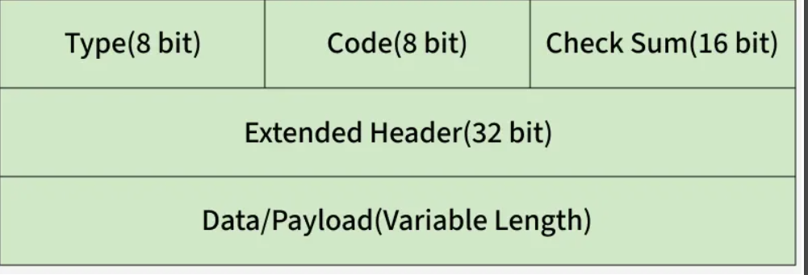
- Type (8-bit): The initial 8-bit of the packet is for message type, it provides a brief description of the message so that receiving network would know what kind of message it is receiving and how to respond to it. Some common message types are as follows:
Type 0 - Echo reply
Type 3 - Destination unreachable
Type 5 - Redirect Message
Type 8 - Echo Request
Type 11 - Time Exceeded
Type 12 - Parameter problem
- Code (8-bit): Code is the next 8 bits of the ICMP packet format, this field carries some additional information about the error message and type.
- Checksum (16-bit): Last 16 bits are for the checksum field in the ICMP packet header. The checksum is used to check the number of bits of the complete message and enable the ICMP tool to ensure that complete data is delivered.
- The next 32 bits of the ICMP Header are Extended Header which has the work of pointing out the problem in IP Message. Byte locations are identified by the pointer which causes the problem message and receiving device looks here for pointing to the problem.
- The last part of the ICMP packet is Data or Payload of variable length. The bytes included in IPv4 are 576 bytes and in IPv6, 1280 bytes.

ii) IGMP
In computer networks (CNS), the Internet Group Management Protocol (IGMP) is a communication protocol that allows devices (hosts) on a network to tell their local router which specific data streams they want to receive.
IGMP Explained in Simple Words
Think of IGMP as a TV remote control for your network:
- Multicasting (Cable TV Service): Normal internet traffic is like ordering a specific movie (unicast). Multicasting is like the cable TV company sending all channels to your neighborhood at once. If everyone gets every channel, it clogs up the network (broadcasting).
- The Router (The Cable Box): Your local router receives all this potential data (all the "channels").
- You (The Host/Device): You use IGMP (the remote) to tell the cable box (router) which specific channel you want to watch.
- Efficiency: The router, using information gathered via IGMP, only sends the requested channel's data to your specific TV (device), instead of sending all channels to all devices. This saves a lot of network bandwidth and prevents slowdowns.
Key Functions
IGMP enables the efficient delivery of data for one-to-many applications, such as:
- Live video streaming
- Online gaming
- Video conferencing
It achieves this through simple message types:
- "Join Group" (Membership Report): A device sends this message when it wants to start receiving a specific data stream.
- "Leave Group": A device sends this when it's done watching (leaves the group).
- "Are you still watching?" (Membership Query): The router periodically asks the devices if they are still interested in their groups to keep its list updated.
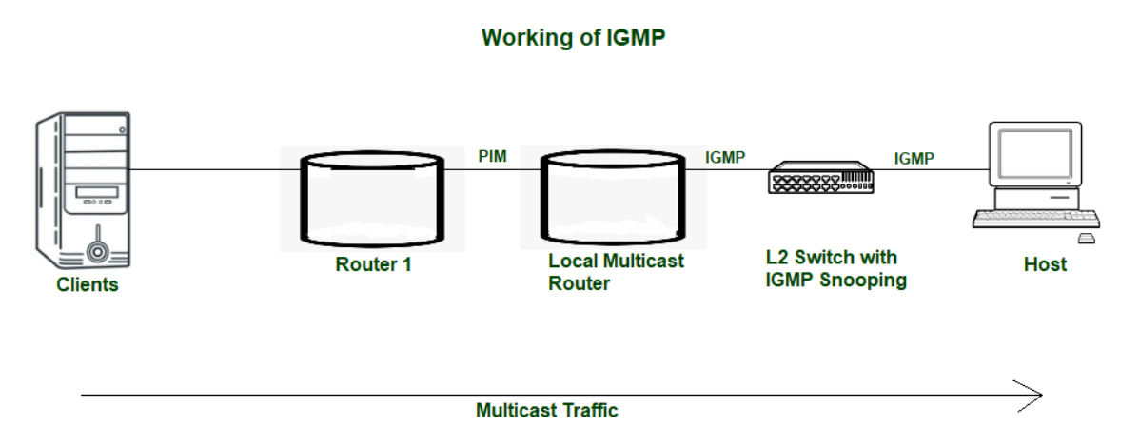
In essence, IGMP is the system that manages who is in which "club" so the network can send data only to the members, not everyone

1. IGMPv1

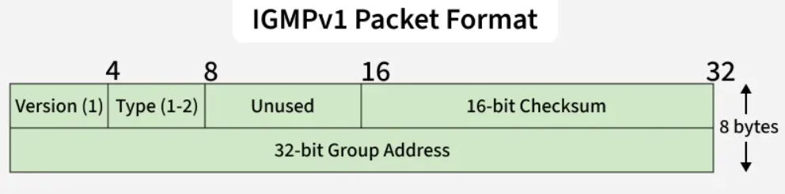
IGMPv1 Packet Format
- Hosts join multicast groups using membership requests.
- No explicit leave option — hosts wait for timeout.
- Fields: Version, Type, Unused, Checksum, Group Address.
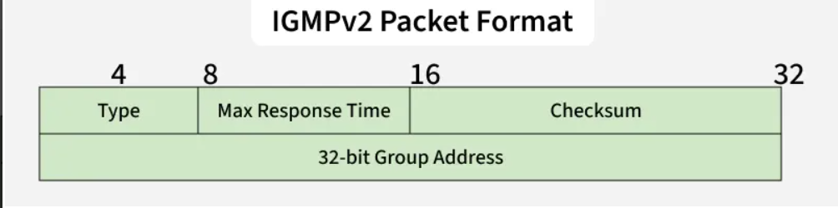
2. IGMPv2

- Adds Leave Group message for faster group exit.
- Supports General, Group-specific and Source-specific queries.
- Fields: Type, Max Response Time, Checksum, Group Address.

iii)ARP
Address Resolution Protocol (ARP) is like a digital "phone book" for local networks, finding a device's physical (MAC) address when you only know its logical (IP) address, so data packets can get to the right place. It works by asking, "Who has IP address X?" to the network; the device with that IP replies with its MAC address (e.g., "I do! Here's my MAC: AA:BB:CC:DD:EE:FF"), and your computer saves this pair in its cache for future use, making communication faster.
Simple Analogy: Finding a Friend in a Building
- You know their Name (IP Address): You want to send a letter to John (IP: 192.168.1.5) in the same building (network).
- You need their Apartment Number (MAC Address): You don't know John's apartment number, just his name.
- ARP Request (Asking the Doorman): You ask the building's doorman (network switch): "Does anyone have John's (192.168.1.5) apartment number?"
- ARP Reply (John Responds): John (the only one with that IP) hears you and tells the doorman, "I'm John! My apartment number is 3B (MAC: AA:BB:CC:DD:EE:FF)."
- Cache (Doorman Remembers): The doorman writes down: "John = Apt 3B" so he doesn't have to ask again for a while.
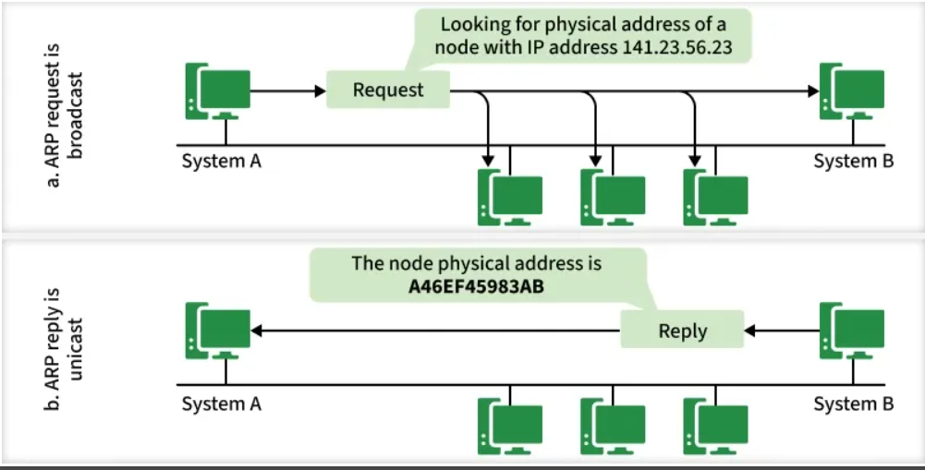
- Delivery (Data Sent): Now you can send your letter directly to Apt 3B (MAC address).
ARP Protocol
How ARP Works
The working of ARP can be explained in the following steps:
- Sender checks ARP Cache: If the MAC address for the destination IP is already cached, communication starts immediately.
- ARP Request Broadcast: If not cached, the sender broadcasts an ARP request on the LAN.
- All Devices Receive Request: Each device checks whether the requested IP matches its own.
- Destination Replies: The device with the matching IP sends an ARP reply (unicast) containing its MAC address.
- Cache Update: The sender updates its ARP cache with the new MAC address for future use.

Key Concepts
- IP Address: The logical address (like a street address) used for routing across networks.
- MAC Address: The physical, unique hardware address (like a specific apartment number) for devices on the same local network (LAN).
- ARP Cache: A temporary memory (table) on your computer storing recent IP-to-MAC pairings for quick access, avoiding repetitive questions.
- ARP Request: A broadcast message (sent to everyone) asking for a MAC address.
- ARP Reply: A direct message (unicast) from the target device with its MAC address.
ARP is crucial because devices communicate using both IP (for general addressing) and MAC (for direct, local delivery

iv) RARP
RARP (Reverse Address Resolution Protocol) was a networking protocol that allowed a device to figure out its unique IP address when it only knew its physical hardware address (called a MAC address).
Think of it as finding your street address when you only know your name:
The Purpose
In the past, some computers called "diskless workstations" didn't have a hard drive to save their configuration files, including their IP address. When these devices started up, they only knew their built-in MAC address. RARP was the solution for these machines to join the network.
How it Worked (The Process)
- Request: The diskless device sends a broadcast message to all other devices on the local network saying, "Here is my MAC address. Can someone tell me my IP address?".
- Server: A special computer on the network, called a RARP server, receives the request. This server maintains a table that maps all known MAC addresses to their corresponding IP addresses.
- Reply: The RARP server looks up the device's MAC address in its table. If it finds a match, it sends a reply message back to the requesting device containing its assigned IP address.
- Configuration: The device receives the IP address and uses it to fully join and communicate on the network.
RARP Today
RARP is now considered obsolete. It had limitations, such as only providing an IP address and nothing else (like a subnet mask or gateway information), and requiring a server on every physical network segment.
It has been replaced by more advanced and flexible protocols:
- BOOTP (Bootstrap Protocol)
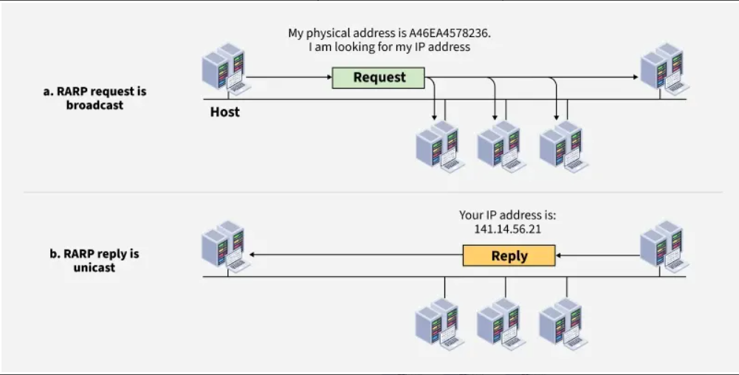
- DHCP (Dynamic Host Configuration Protocol), which is the standard protocol used in almost all modern networks today for automatic IP address assignment.
RARP

Working of RARP
Reverse ARP (RARP) is a network protocol used by a client machine in a local area network (LAN) to obtain its Internet Protocol (IP) address from the gateway router's ARP (Address Resolution Protocol) table. When a machine doesn't have the memory to store its IP address, such as diskless machines or newly configured systems, it uses RARP to request an IP address.
- RARP Request: A client broadcasts a RARP request containing its MAC address.
- Server Lookup: A RARP server (or gateway router with ARP table) checks its mapping of MAC -> IP.
- RARP Reply: If a match is found, the server responds with the client’s IP address.
- Client Configuration: The client configures itself with the provided IP and can now communicate on the network.

v)BGP
BGP, or Border Gateway Protocol, is the postal service of the internet [1]. It is a standardized exterior gateway protocol designed to exchange routing and reachability information among autonomous systems (AS) on the internet [2].
In simple terms:
- Autonomous Systems (AS): Think of these as individual countries or states. Examples include large Internet Service Providers (ISPs) like AT&T or Verizon, or major tech companies like Google or Microsoft. Each has its own network infrastructure [1].
- BGP's Role: BGP acts as the 'post office' that connects these 'countries' (autonomous systems) [1]. Its main job is to figure out the most efficient, reliable, and policy-compliant path for data to travel from one AS to another [2].
- How It Works:
  - When you send a request to visit a website (e.g., Google.com), your request starts within your local AS (your home ISP) [1].
  - Your ISP uses BGP to "ask around" and find the fastest route through other networks to Google's AS [1].
  - BGP considers various factors—like how many 'hops' (networks) it has to cross, existing agreements between ISPs, and network policies—to choose the best path [2].
  - It's like GPS for your data, but instead of navigating roads, it navigates complex global networks [1].
Ultimately, BGP is the critical, underlying protocol that makes the entire global internet interconnected and functional by directing where data should go
Types of Border Gateway Protocol
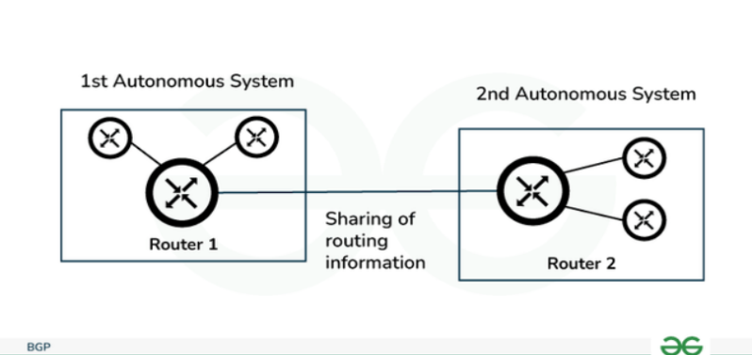
1. External BGP
It is used to interchange routing information between the routers in different autonomous systems, it is also known as eBGP(External Border Gateway Protocol). The below image shows how eBGP interchange routing information.
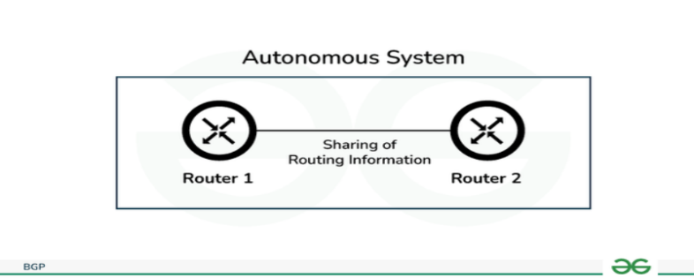
2. Internal BGP

It is used to interchange routing information between the routers in the same autonomous system, it is also known as iBGP(Internal Border Gateway Protocol). Internal routers also ensure consistency among routers for sharing routing information. The below image shows how iBGP interchange routing information.

vi)RIP
RIP (Routing Information Protocol) is a simple, older network protocol that helps routers find the best path to send data across a small network. It works by counting the number of routers (hops) to a destination and always chooses the path with the fewest hops.
How RIP Works (Simplified)
Imagine a network of interconnected roads (connections) and intersections (routers). RIP is like a simple navigation system for the routers:
- Sharing Maps (Routing Tables): Every 30 seconds, each router shouts out its entire road map (routing table) to its immediate neighbors.
- Counting Hops: When a router gets a map from a neighbor, it adds one "hop" to all the routes in that map. A "hop" is simply one pass through a router.
- Choosing the Best Path: The router compares the new routes it just learned with the routes it already has. If it finds a shorter route (fewer hops) to a destination, it updates its own map with the better path.
- Limited Range: The map only tracks routes up to 15 hops away. A destination that is 16 hops or more is considered unreachable, which helps prevent data from endlessly looping around a large network.
Key Features
- Metric: Uses hop count (number of routers) as the only way to measure distance.
- Updates: Sends out periodic updates of its entire routing table every 30 seconds.
- Simplicity: It is very easy to configure and manage, making it a good learning tool or suitable for small, simple networks.
- Versions:
  - RIPv1: The original version, which doesn't send subnet information and uses broadcasts.
  - RIPv2: An improved version that supports subnet masks (classless routing) and uses more efficient multicasts for updates.
  - RIPng: A version designed to support the newer IPv6 addresses.
Limitations
- Not Scalable: The 15-hop limit makes it unsuitable for large, complex networks.
- Slow to Adapt: It takes time for all routers to learn about network changes (slow convergence), which can temporarily lead to inefficient routing.
- Inefficient Metric: It only considers hop count, not the actual speed or bandwidth of a connection. A path with three slow hops might be chosen over a path with four very fast hops.
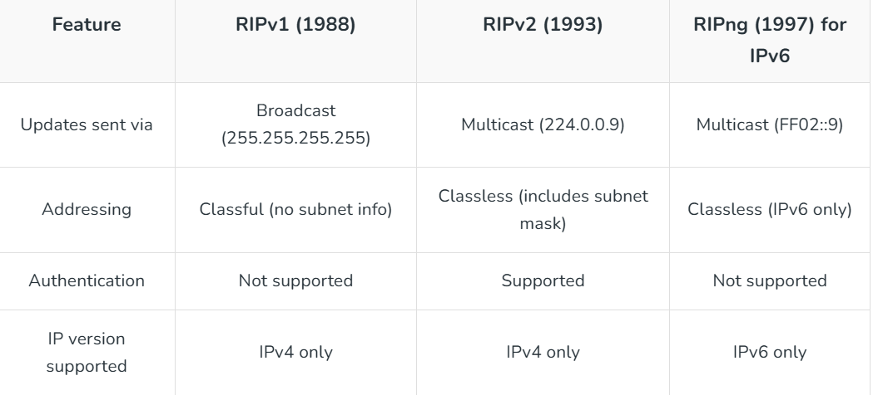
- Types of RIP Versions

vii)Mobile IP
Mobile IP is a networking protocol that allows mobile devices (like smartphones or laptops) to move between different networks (e.g., from Wi-Fi to cellular data) without losing their internet connection or changing their permanent IP address.
Think of it like having a permanent phone number that always works, no matter which city you are physically in. The system in the background makes sure calls are routed correctly to your current location.
Why is it needed?
Normally, your device's IP address is tied to a specific network location. If you move to a new network, your IP address should technically change, which would disrupt ongoing communications like video calls, downloads, or VPN sessions. Mobile IP solves this by making the movement "transparent" to your applications, so your connection stays active without interruption.
Key Components
- Mobile Node (MN): This is your mobile device (laptop, phone, etc.) that moves between networks.
- Home Address: This is the permanent IP address assigned to your device in its home network. It stays the same no matter where you go.
- Home Agent (HA): This is a router in your home network. It acts as an anchor point and keeps track of your device's current location when it is away from home.
- Foreign Agent (FA): This is a router in the network you are currently visiting. It helps your device connect to the visited network and relays information to your Home Agent. (In some cases, the mobile device can act as its own Foreign Agent, using a "co-located" care-of address).
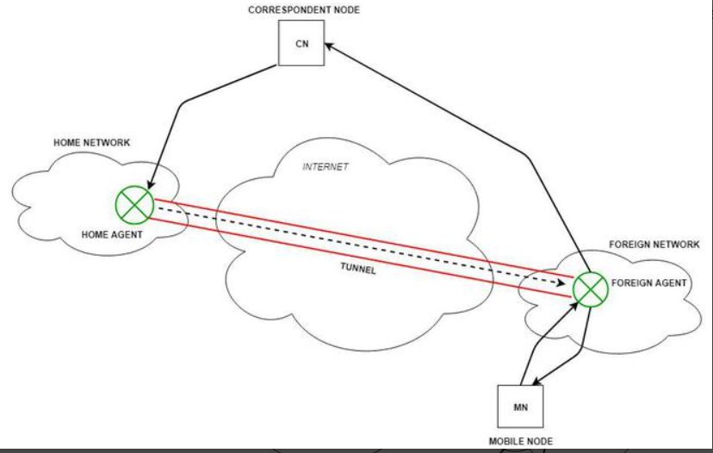
- Care-of Address (CoA): This is a temporary IP address assigned to your device in the foreign network. It tells the Home Agent where to send your data packets.

How It Works (in simple steps)
- Discovery: When your device enters a new (foreign) network, it detects the presence of a Foreign Agent (FA) and gets a temporary Care-of Address (CoA).
- Registration: Your device sends a registration request to its Home Agent (HA) (usually through the FA), informing the HA of its new CoA. The HA updates its records, creating a "binding" between your permanent home address and your temporary CoA.
- Tunneling (Data Transfer): When someone sends data to your device's permanent home address:
  - The data first arrives at your Home Agent.
  - The HA "wraps" the original data packet inside a new packet with a new header, using your CoA as the destination address. This process is called tunneling.
  - The wrapped packet travels through the internet to the Foreign Agent (or directly to your device if it's using a co-located CoA).
  - The Foreign Agent "unwraps" the packet (decapsulation) and delivers the original data to your device.
- Sending Data Back: When your device sends data back, it often sends it directly to the recipient using standard IP routing, which can sometimes create a "triangle" route.
This entire process happens automatically in the background, allowing you to move seamlessly without dropping your connection.
viii) MPLS
Multiprotocol Label Switching (MPLS) is a networking technique that acts like a high-speed, predetermined highway for data packets. Instead of relying on complex lookups at every single router hop, it assigns short, simple "labels" to data packets, allowing them to be forwarded quickly along a specific, established path.
Note: MPLS lies between Layer 2 (Data Link) and Layer 3 (Network Layer) of the OSI model, which is why it is often referred to as a Layer 2.5 protocol.
How MPLS Works (Simplified Analogy)
Imagine sending a parcel through a complex city:
- Traditional IP Routing is like a delivery van driver stopping at every intersection, opening their map (routing table), figuring out the next street to take based on the destination address, and moving on. This happens repeatedly at every intersection, which can be slow.
- MPLS is like a dedicated express lane or a private rail system. At the entry point (the first "edge" router), the parcel is given a special colored sticker or "label" that indicates its entire pre-planned route through the system. Intermediate routers just need to read this simple label to know exactly where to send it next, without needing to check a complex map every time. At the exit point, the label is removed, and the parcel goes to its final destination.
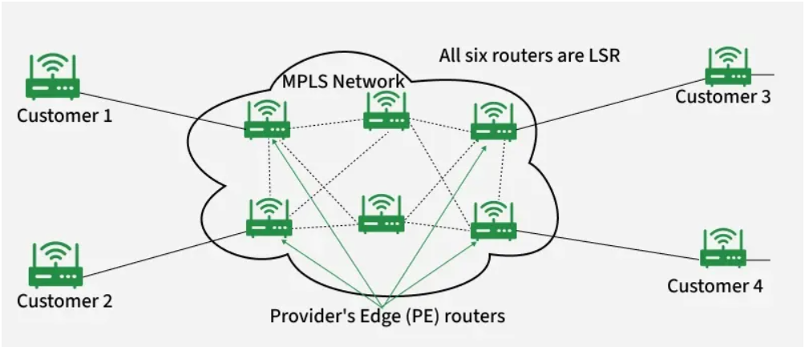
Key Components
- Labels: Short, fixed-length identifiers added to each data packet, which contain forwarding information and priority levels.
- Label-Switched Path (LSP): The predetermined, one-way route that packets with the same label follow through the network.
- Label Edge Routers (LERs): Routers at the entry (ingress) and exit (egress) points of the MPLS network that add (push) or remove (pop) the labels.
- Label Switch Routers (LSRs): Core routers within the MPLS network that simply read the label and swap it for a new one as the packet moves to the next hop.
Benefits
- Improved Performance/Reduced Latency: By avoiding complex, hop-by-hop IP address lookups, MPLS forwards data packets much faster, which is crucial for real-time applications like voice (VoIP) and video conferencing.
- Quality of Service (QoS): Network administrators can prioritize certain types of traffic (e.g., giving voice data VIP treatment over email traffic) to ensure consistent performance.
- Traffic Engineering: Allows network operators to control and balance traffic flow across the network efficiently, avoiding congestion.
- Multiprotocol Support: It's "multiprotocol" because it can carry various types of network traffic (IP, Ethernet, etc.) over the same infrastructure.

ix) OSPF
OSPF (Open Shortest Path First) is a common interior gateway protocol (IGP) used by routers within a single autonomous system—typically within one organization or company network—to figure out the best way to send data packets efficiently [2]. It is essentially a sophisticated "GPS" system for an internal network.
Here is an explanation in simple terms:
The Analogy: A Delivery Company's Internal Map
Imagine a large delivery company with several local branches (routers) in a city. They need an efficient, real-time map to decide the fastest route for every package. OSPF is the system they use to build and maintain this map.
How OSPF Works (Step-by-Step)
- "Hello, Neighbor!" (Discovering Neighbors):
  - When a router running OSPF boots up, it broadcasts a "Hello" message to find other OSPF routers nearby. They exchange greetings and form a direct relationship called an adjacency.
- Sharing Local Routes (Link State Advertisements - LSAs):
  - Once connected, each router shares its local information. It doesn't send the full map of the city; it only announces the roads directly connected to itself and how "expensive" those roads are to use (the cost or metric) [1, 2].
  - These little information packets are called Link State Advertisements (LSAs).
- Building the Full Map (Link State Database - LSDB):
  - Every single router collects all the LSAs from all its neighbors.
  - It compiles these little pieces of information into one complete, identical map of the entire company network. This shared map is called the Link State Database (LSDB) [2].
- Calculating the Best Route (Dijkstra's Algorithm):
  - With the complete map (LSDB) in hand, each router uses a special mathematical algorithm called Dijkstra's algorithm to calculate the shortest and fastest path from itself to every other destination in the network [2].
  - The "cost" of a route is based on factors like bandwidth (a fiber-optic line costs less to use than a slow DSL line).
- Putting it in the GPS (Routing Table):
  - The router picks the absolute best paths it calculated and puts them into its routing table. This table is the actual "GPS instructions" it uses every time a data packet comes in.

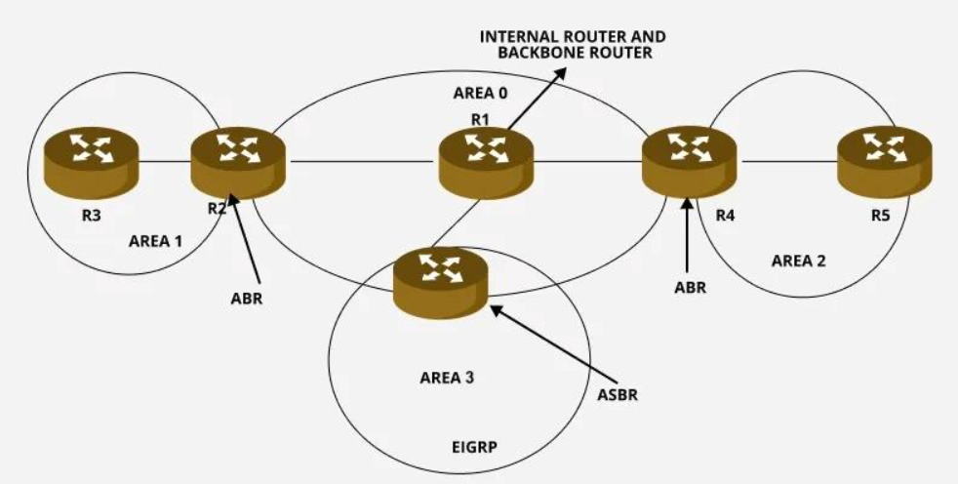
OSPF Network Topology
Internal Router
- An Internal Router is a router that operates entirely within a single OSPF area. It only exchanges routing information within that area and does not participate in routing between areas.
- Internal routers have interfaces that are solely part of one area. They only maintain the OSPF topology table for the area they belong to and do not handle inter-area routing. Their primary function is to manage routing within the same OSPF area.
Backbone Router
- A Backbone Router is responsible for connecting multiple OSPF areas to the backbone area (Area 0). It plays a critical role in ensuring communication between routers in different OSPF areas.
- Backbone routers aggregate and summarize routes between areas, helping optimize the routing process by reducing the size of routing tables and minimizing unnecessary route advertisements across the OSPF network.
Area Border Router (ABR)
An Area Border Router (ABR) is a router that connects multiple OSPF areas, including the backbone area (Area 0). ABRs perform the essential function of distributing routing information between areas and managing the exchange of routing data. These routers also summarize inter-area routes to prevent excessive route advertisements and keep OSPF routing tables efficient.
Autonomous System Boundary Router (ASBR)
- An ASBR is a router that connects an OSPF Autonomous System (AS) to external networks, such as other routing protocols like EIGRP or BGP. It plays a pivotal role in integrating OSPF with external routing environments.

Key Benefits of OSPF
- Fast Convergence: If a road (network link) goes down, the routers quickly send out new LSAs, rebuild their maps, and find a new route almost instantly [1].
- Efficiency: It only sends changes when the network changes, rather than sending the entire map repeatedly.
- Scalability: OSPF can manage very large and complex networks effectively by dividing them into smaller, manageable areas [1].
In short, OSPF ensures that all routers within an organization agree on the fastest and most efficient way to route all network traffic.
Q. Explain Link state routing
Link State Routing is like every router getting a detailed map of the whole network, knowing who's connected to whom and the "cost" (speed/distance) to reach them, then using that map (via Dijkstra's Algorithm) to find the absolute shortest path for data, unlike older methods that just asked neighbors. Routers broadcast their link status (up/down, cost) as Link State Packets (LSPs) to everyone, building a shared picture (Link State Database) for smart, loop-free routing.
How it Works (Simple Steps)
- Hello & Discovery: Routers send "Hello" messages to neighbors to find out who's directly connected and learn link costs (e.g., speed, congestion).
- Create LSPs (Link State Packets): Each router creates a summary (Link State Advertisement or LSP) listing its direct links and their costs, plus a unique sequence number.
- Flood LSPs: Routers broadcast these LSPs to everyone in the network, ensuring all routers get the same, complete map.
- Build the Map: Each router uses these LSPs to build its own complete map (Link State Database) of the entire network topology.
- Calculate Shortest Path (Dijkstra's): Using the map, each router runs Dijkstra's algorithm (like finding the shortest driving route on a map) to find the best path to every other destination.
- Forward Data: Data packets are then sent along these calculated shortest paths.
Key Idea: The Shared Map
Instead of just knowing about neighbors (like Distance Vector), Link State gives every router a full, global view, allowing for more intelligent, efficient routing decisions and preventing stuck loops.
Q.Explain Distance vector routing.
Distance Vector Routing (DVR) is like asking your neighbors for directions: each router shares its list (vector) of distances (hops/cost) to all destinations with its immediate neighbors, who then update their own lists, adding their own hop and choosing the best path, repeating until everyone knows the best route, using the Bellman-Ford algorithm to find the shortest path, often just by hop count.
How it works (Simple Analogy)
- You & Neighbors: Imagine you're in a city with several nearby towns (routers). Each town knows how far away other towns are.
- Sharing Info: Every few minutes, your town shouts its distance list (e.g., "Town C is 2 towns away, Town D is 3 towns away") to your direct neighbors.
- Updating Your Map: Your town listens, adds 1 (for your town) to each distance received from a neighbor, and updates its own map if it finds a shorter path (e.g., if a neighbor says Town C is 3 away, but you thought it was 4, you update to 3).
- Vector = (Distance, Next Hop): The "vector" part means your map has: a distance (e.g., 2 hops) and a next hop (e.g., go to Neighbor X).
- "Routing by Rumor": Routers don't know the whole network map; they rely on neighbors' information, like getting directions by rumor.
How Distance Vector Algorithm works?
1. Routers share information: Each router sends its distance vector to all its neighbors.
2. Routers update information:
- When a router receives a neighbor’s table, it saves it.
- If new information changes the shortest path, the router updates its own table.
- Updates also occur if a link goes down.
$$D_{x}(y)=min⁡\{C(x,v)+D_{v}(y)\}$$
3. Distance calculation:
The cost of reaching a destination is calculated using the Bellman-Ford equation:
Where:
- Dx​(y) = cost from router x to destination y
- C(x,v) = cost from router x to neighbor v
- Dv(y)= cost from neighbor v to destination y
Example: Consider 3-routers X, Y and Z as shown in figure. Each router have their routing table. Every routing table will contain distance to the destination nodes.
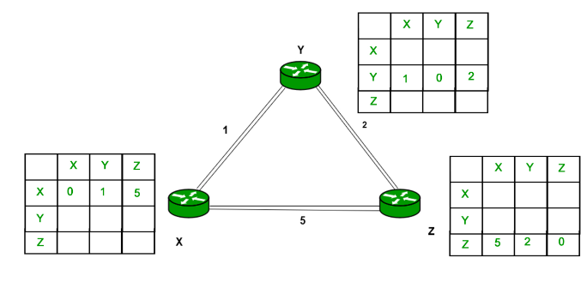
Consider router X , X will share it routing table to neighbors and neighbors will share it routing table to it to X and distance from node X to destination will be calculated using bellmen- ford equation.
Dx(y) = min { C(x,v) + Dv(y)} for each node y ? N
As we can see that distance will be less going from X to Z when Y is intermediate node(hop) so it will be update in routing table X.
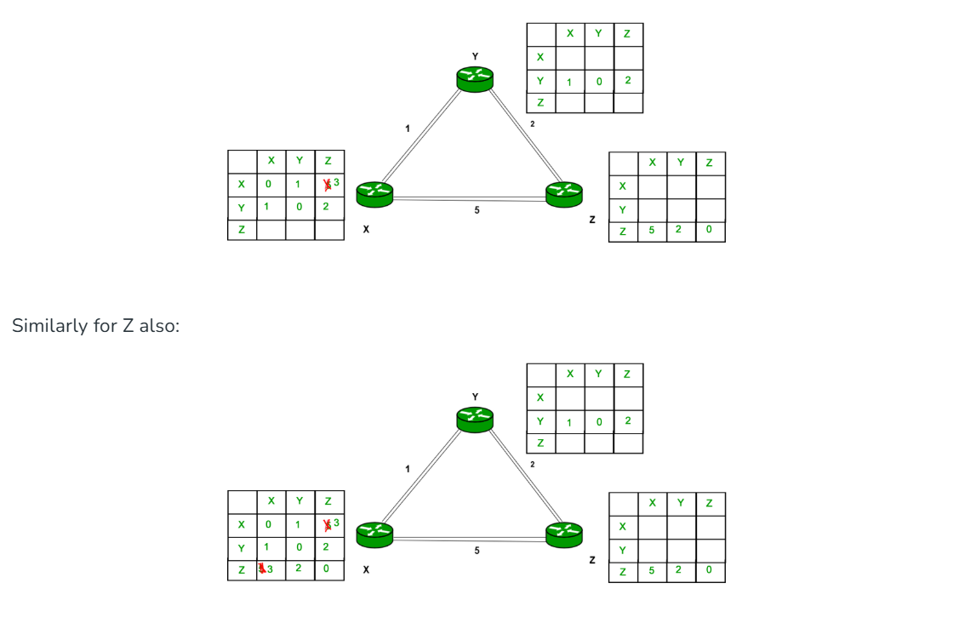
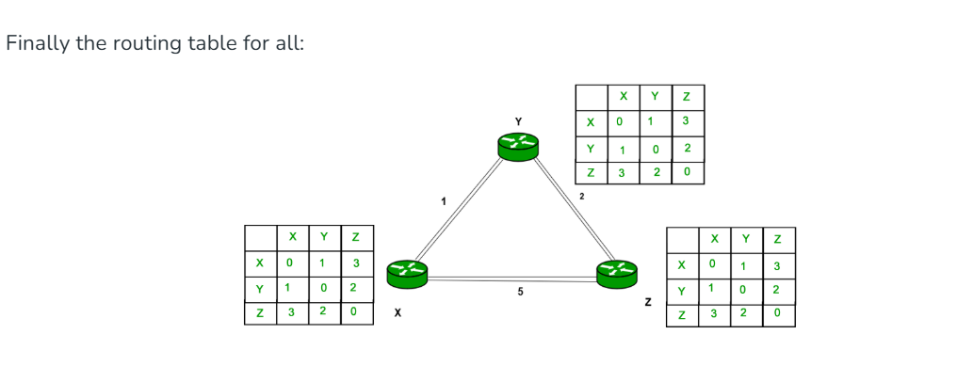
Key Points
- Metric: Usually hop count (number of routers).
- Updates: Periodic (e.g., every 30 secs) table exchanges with neighbors.
- Algorithm: Uses Bellman-Ford.
- Pros: Simple to understand.
- Cons: Slow to converge, prone to routing loops (Count-to-Infinity problem) if not careful.
Example (RIP)
The old Routing Information Protocol (RIP) is a classic Distance Vector protocol, using hop count as its distance metric and broadcasting its routing table every 30 seconds.

Q.Differentiate between Circuit Switching, Message Switching and Packet Switching.
Basics | Circuit Switching | Message Switching | Packet Switching
Connection Creation | Connection is created between the source and destination by establishing a dedicated path between source and destination. | Links are created independently one by one between the nodes on the way. | Links are created independently one by one between the nodes on the way.
Queuing | No queue is formed. | Queue is formed. | Queue is formed.
Message and Packets | There is one big entire data stream called a message. | There is one big entire data stream called a message. | The big message is divided into a small number of packets.
Routing | One single dedicated path exists between the source and destination. | Messages follow the independent route to reach a destination. | Packets follow the independent path to hold the destination.
Addressing and sequencing | Messages need not be addressed as there is one dedicated path. | Messages are addressed as independent routes are established. | Packets are addressed, and sequencing is done as all the packets follow the independent route.
Propagation Delay | No | Yes | Yes
Transmission Capacity | Low | Maximum | Maximum
Sequence Order | Message arrives in Sequence. | Message arrives in Sequence. | Packets do not appear in sequence at the destination.
Use Bandwidth | Wastage | Bandwidth is used to its maximum extent. | Bandwidth is used to its maximum extent.

Q. Draw and explain Header format of IPV6.
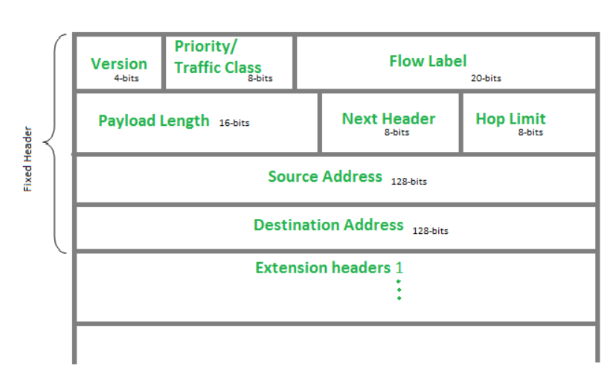
The IPv6 header is the first part of an IPv6 packet, containing essential information for routing and delivering the packet across networks. The IPv6 header representation is a structured layout of fields in an IPv6 packet, including source and destination addresses, traffic class, flow label, payload length, next header, and hop limit. It ensures proper routing and delivery of data across networks.
IPv6 Fixed Header
The IPv6 header is a part of the information sent over the internet. It's always 40 bytes long and includes details like where data should go and how it should get there. This helps devices talk to each other and share information smoothly online.
Version (4-bits)
The size of this field is 4-bit. Indicates the version of the Internet Protocol, which is always 6 for IPv6, so the bit sequence is 0110.
Traffic Class(8-bit)
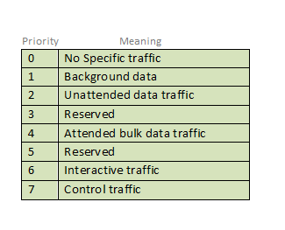
The Traffic Class field indicates class or priority of IPv6 packet which is similar to Service Field in IPv4 packet. It helps routers to handle the traffic based on the priority of the packet. If congestion occurs on the router then packets with the least priority will be discarded.
As of now, only 4-bits are being used (and the remaining bits are under research), in which 0 to 7 are assigned to Congestion controlled traffic and 8 to 15 are assigned to Uncontrolled traffic.
Priority assignment of Congestion controlled traffic :

Uncontrolled data traffic is mainly used for Audio/Video data. So we give higher priority to Uncontrolled data traffic.
The source node is allowed to set the priorities but on the way, routers can change it. Therefore, the destination should not expect the same priority which was set by the source node.
Flow Label (20-bits)
Flow Label field is used by a source to label the packets belonging to the same flow in order to request special handling by intermediate IPv6 routers, such as non-default quality-of-service or real-time service. In order to distinguish the flow, an intermediate router can use the source address, a destination address, and flow label of the packets. Between a source and destination, multiple flows may exist because many processes might be running at the same time. Routers or Host that does not support the functionality of flow label field and for default router handling, flow label field is set to 0. While setting up the flow label, the source is also supposed to specify the lifetime of the flow.
Payload Length (16-bits)
It is a 16-bit (unsigned integer) field, indicates the total size of the payload which tells routers about the amount of information a particular packet contains in its payload. The payload Length field includes extension headers(if any) and an upper-layer packet. In case the length of the payload is greater than 65,535 bytes (payload up to 65,535 bytes can be indicated with 16-bits), then the payload length field will be set to 0 and the jumbo payload option is used in the Hop-by-Hop options extension header.
Next Header (8-bits)
Next Header indicates the type of extension header(if present) immediately following the IPv6 header. Whereas In some cases it indicates the protocols contained within upper-layer packets, such as TCP, UDP.
Hop Limit (8-bits)
Hop Limit field is the same as TTL in IPv4 packets. It indicates the maximum number of intermediate nodes IPv6 packet is allowed to travel. Its value gets decremented by one, by each node that forwards the packet and the packet is discarded if the value decrements to 0. This is used to discard the packets that are stuck in an infinite loop because of some routing error.
Source Address (128-bits)
Source Address is the 128-bit IPv6 address of the original source of the packet.
Destination Address (128-bits)
The destination Address field indicates the IPv6 address of the final destination(in most cases). All the intermediate nodes can use this information in order to correctly route the packet.
Extension Headers
In order to rectify the limitations of the IPv4 Option Field, Extension Headers are introduced in IP version 6. The extension header mechanism is a very important part of the IPv6 architecture. The next Header field of IPv6 fixed header points to the first Extension Header and this first extension header points to the second extension header and so on.
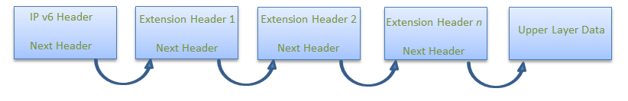
Q. List and explain functions of Network Layer .
The Network Layer (Layer 3) in networking finds the best path for data (packets) to travel between different networks, acting like a GPS for the internet, using IP addresses for identification, performing routing to direct traffic, handling fragmentation (breaking data down) and reassembly, and providing basic error checking, all to ensure data gets from source to destination across the vast web of interconnected networks, mainly via devices called routers.
Here are its key functions explained simply:
- Logical Addressing (IP Addressing):
  - What it does: Gives every device a unique, logical address (like an IP address, e.g., 192.168.1.1) so they can be found across different networks.
  - Simple Analogy: This is like the house number and street name on a letter, ensuring it goes to the right building.
- Routing:
  - What it does: Determines the best path (route) for data packets to travel from the source network to the destination network, often across many hops (routers).
  - Simple Analogy: Like a GPS finding the fastest route on a map, routers decide which roads (connections) to take.
- Forwarding:
  - What it does: Moves packets from one network to another based on the routing decisions made.
  - Simple Analogy: The mail carrier taking your letter from your street to the main post office, then to the next city's post office.
- Fragmentation & Reassembly:
  - What it does: If a data packet is too big for a specific link, the network layer breaks it into smaller pieces (fragments) and puts them back together (reassembles) at the destination.
  - Simple Analogy: Cutting a large document into several smaller pages to fit in an envelope, then taping them back together on arrival.
- Error Handling & Diagnostics:
  - What it does: Detects and manages errors during packet delivery (like lost packets) and provides status information, though the Transport Layer does more robust error control.
  - Simple Analogy: Noticing a damaged envelope and flagging it for the next step, but not necessarily fixing the letter inside.
- Encapsulation:
  - What it does: Takes data from the layer above (Transport Layer) and wraps it in a Network Layer "header" (containing IP addresses and routing info) to create a packet.
  - Simple Analogy: Putting your letter (data) inside a new envelope (packet header) with addresses.
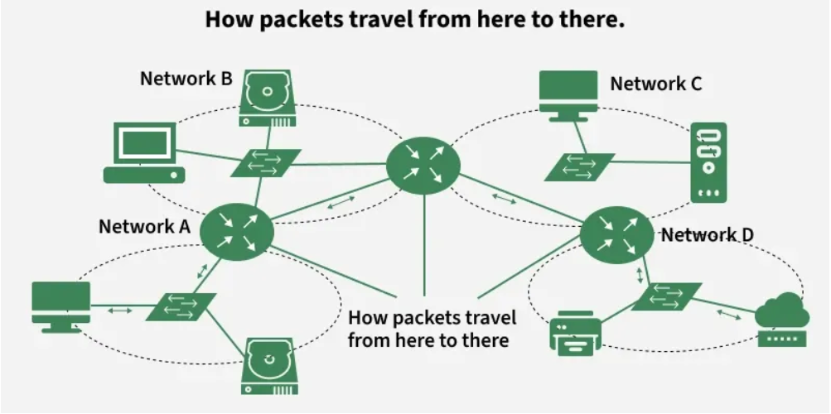
In essence, the Network Layer is the backbone of internet communication, connecting disparate networks and making sure your data finds its way efficiently from your computer to any other device on Earth.

- Each device is assigned a unique logical address (IP address).
- Data from the transport layer is encapsulated into packets, with source and destination IPs attached.
- Routers analyze the destination address and determine the best available path.
- Packets traverse the network hop-by-hop, moving across routers until reaching the destination.
- If the packet size exceeds the MTU, it is fragmented into smaller units.
- At the destination, the fragments are reassembled into the original data.
- If errors occur (e.g., unreachable destination), protocols like ICMP send error messages back to the source.

Q. Explain Link state routing.
Link State Routing is like every router getting a detailed map of the whole network, knowing who's connected to whom and the "cost" (speed/distance) to reach them, then using that map (via Dijkstra's Algorithm) to find the absolute shortest path for data, unlike older methods that just asked neighbors. Routers broadcast their link status (up/down, cost) as Link State Packets (LSPs) to everyone, building a shared picture (Link State Database) for smart, loop-free routing.
How it Works (Simple Steps)
- Hello & Discovery: Routers send "Hello" messages to neighbors to find out who's directly connected and learn link costs (e.g., speed, congestion).
- Create LSPs (Link State Packets): Each router creates a summary (Link State Advertisement or LSP) listing its direct links and their costs, plus a unique sequence number.
- Flood LSPs: Routers broadcast these LSPs to everyone in the network, ensuring all routers get the same, complete map.
- Build the Map: Each router uses these LSPs to build its own complete map (Link State Database) of the entire network topology.
- Calculate Shortest Path (Dijkstra's): Using the map, each router runs Dijkstra's algorithm (like finding the shortest driving route on a map) to find the best path to every other destination.
- Forward Data: Data packets are then sent along these calculated shortest paths.
Key Idea: The Shared Map
Instead of just knowing about neighbors (like Distance Vector), Link State gives every router a full, global view, allowing for more intelligent, efficient routing decisions and preventing stuck loops
Q.Draw and explain Header format of IPV4.
IP stands for Internet Protocol and v4 stands for Version Four (IPv4). IPv4 was the primary version brought into action for production within the ARPANET in 1983. IP version four addresses are 32-bit integers which will be expressed in decimal notation. In this article, we will discuss about IPv4 datagram header.
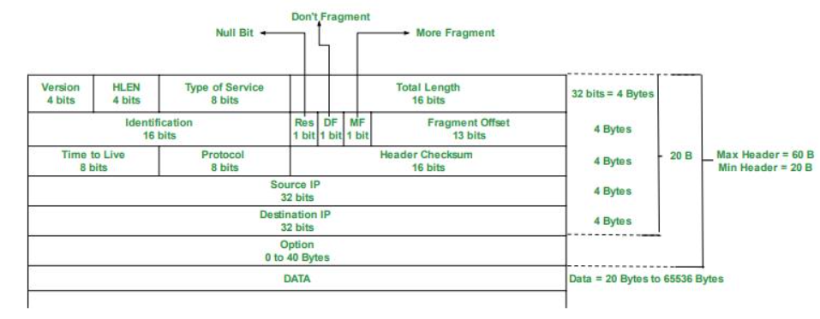
- VERSION: Version of the IP protocol (4 bits), which is 4 for IPv4
- HLEN: IP header length (4 bits), which is the number of 32 bit words in the header. The minimum value for this field is 5 and the maximum is 15.
- Type of service: Low Delay, High Throughput, Reliability (8 bits)
- Total Length: Length of header + Data (16 bits), which has a minimum value 20 bytes and the maximum is 65,535 bytes.
- Identification: Unique Packet Id for identifying the group of fragments of a single IP datagram (16 bits)
- Flags: 3 flags of 1 bit each : reserved bit (must be zero), do not fragment flag, more fragments flag (same order)
- Fragment Offset: Represents the number of Data Bytes ahead of the particular fragment in the particular Datagram. Specified in terms of number of 8 bytes, which has the maximum value of 65,528 bytes.
- Time to live: Datagram’s lifetime (8 bits), It prevents the datagram to loop through the network by restricting the number of Hops taken by a Packet before delivering to the Destination.
- Protocol: Name of the protocol to which the data is to be passed (8 bits)
- Header Checksum: 16 bits header checksum for checking errors in the datagram header
- Source IP address: 32 bits IP address of the sender
- Destination IP address: 32 bits IP address of the receiver
- Option: Optional information such as source route, record route. Used by the Network administrator to check whether a path is working or not.

Q. Explain Network Address Translation (NAT) process.
Network Address Translation (NAT) is like a receptionist for your home Wi-Fi, letting many devices (phones, laptops) use one public internet address (your router's) by swapping private internal addresses for that single public one when they go online, and vice versa when data comes back, saving IP addresses and adding a security layer by hiding your devices.
The Simple NAT Process (Think of a Mailroom)
- Sending a Request (Leaving the Network):
  - Your Laptop (Private IP: 192.168.1.10) wants to visit Google.
  - The request goes to your Router (the NAT device).
  - The Router changes the "From" address on the packet from your Laptop's private IP to its own single public IP (e.g., 203.0.113.5) and maybe assigns a unique port number (e.g., 50001).
  - The Router notes this in a table: "Laptop 192.168.1.10 uses Port 50001".
  - The packet goes to Google with "From: 203.0.113.5:50001".
- Receiving a Reply (Coming Back In):
  - Google sends data back to "203.0.113.5:50001".
  - The Router sees the public IP and port, checks its table, and finds the match: port 50001 belongs to laptop 192.168.1.10.
  - The Router changes the "To" address back to your Laptop's private IP (192.168.1.10) and forwards it.
Note: IPv4 provides only 2³² (about 4.3 billion) addresses, which is insufficient considering the massive number of devices connected to the Internet. NAT prevents IP exhaustion by enabling thousands of private devices to share a limited number of public IP addresses.
Why NAT is Awesome
- IP Address Saver: Instead of every device needing a unique, precious public IP, they all share one, solving the IPv4 address shortage.
- Security Boost: It hides your internal network's IP addresses, making it harder for outsiders to directly attack your devices.
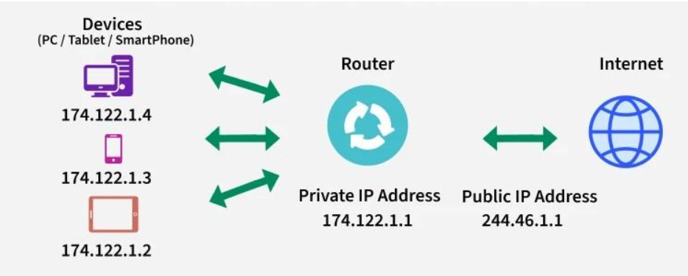
Working of NAT
This explains how NAT functions:
- A device sends a request → reaches the NAT-enabled router.
- Router replaces the private IP with its public IP and assigns a unique port.
- NAT stores this mapping in the NAT table.
- When the server responds, NAT uses the stored entry to send the packet to the correct internal device.
Q.192.168.5.51 / 27 for given address find out the.
i) Subnet mask?
ii) What is first ip address for given series?
iii) What is last ip address for given series?
For IP 192.168.5.51 /27, the subnet mask is 255.255.255.224, the first IP (Network Address) is 192.168.5.32, and the last usable IP (Broadcast Address) is 192.168.5.63, meaning usable range is 192.168.5.33 to 192.168.5.62, used for hosts on this subnet.
Here's the breakdown:
- Subnet Mask (i):
  - /27 means the first 27 bits are for the network, leaving 5 bits for hosts (32 - 27 = 5).
  - In binary: 11111111.11111111.11111111.11100000
  - Converting to decimal: 255.255.255.224 (since 128+64+32 = 224).
- First IP Address (Network Address) (ii):
  - This is the starting point of the subnet. For /27, the block size (increment) is 32 (2^5 = 32).
  - You find the multiple of 32 that 192.168.5.51 falls into.
  - 0, 32, 64...
  - 192.168.5.51 is in the 32 block.
  - Result: 192.168.5.32.
- Last IP Address (Broadcast Address) (iii):
  - This is the end of the subnet block, before the next network starts (which would be 192.168.5.64).
  - You take the network address and add the block size minus one (32 - 1 = 31) to the last octet, or simply find the last address before the next network starts.
  - 192.168.5.32 + 31 = 192.168.5.63 (or the address before the next network's start).
  - Result: 192.168.5.63.

